Ex.no:3 | DATA CLEANING

Aim:

Algorithm:
Check Missing Values:
- Start.
- Import the pandas library.
- Load the dataset into a DataFrame (df).
- Display dataset information using df.info().
- Check missing values using df.isnull().
- Count missing values using df.isnull().sum().
- Check missing values using df.isna().
- Check non-missing values using df.notnull().
- Display the results.

Drop Missing Values
- Start.
- Import the pandas library.
- Load the dataset into a DataFrame (df).
- Drop missing rows using dropna().
- Drop rows (axis=0) or columns (axis=1).
- Use how='any' to remove rows/columns containing any missing value.
- Use how='all' to remove rows/columns only if all values are missing.
- Use thresh=N to keep rows/columns with at least N non-missing values.
- Use subset=['column_name'] to drop rows based on specific columns.
- Use inplace=True to modify the original DataFrame.
- Display the cleaned DataFrame.

Program:
import pandas as pd
# Load dataset
df=pd.read_csv("C:/Users/DELL/Downloads/Sleep_health_and_lifestyle_dataset.csv")
print("\n===== MISSING VALUES IN EACH COLUMN =====")
print(df.isnull())
print(df.isnull().sum())
df["Age"].fillna(df["Age"].mean(), inplace=True)
print(df)
print(df.duplicated()) df.drop_duplicates(inplace=True) print(df)
Q1 = df['Age'].quantile(0.25) Q3 = df['Age'].quantile(0.75)
IQR = Q3 - Q1
lower = Q1 - 1.5 * IQR upper = Q3 + 1.5 * IQR
outliers = df[(df['Age'] < lower) | (df['Age'] > upper)] print(outliers)
Q1 = df['Sleep Duration'].quantile(0.25)
Q3 = df['Sleep Duration'].quantile(0.75)
IQR = Q3 - Q1
lower = Q1 - 1.5 * IQR
upper = Q3 + 1.5 * IQR
outliers = df[(df['Sleep Duration'] < lower) | (df['Sleep Duration'] > upper)]
print(outliers)
from sklearn.preprocessing importMinMaxScaler
scaler = MinMaxScaler()
df[['Age']]=scaler.fit_transform(df[['Age']])
print(df[['Age']])
from sklearn.preprocessing import LabelEncoder
encoder = LabelEncoder()
df['Gender'] = encoder.fit_transform(df['Gender'])
print(df)
pd.get_dummies(df['Gender'])

Output:
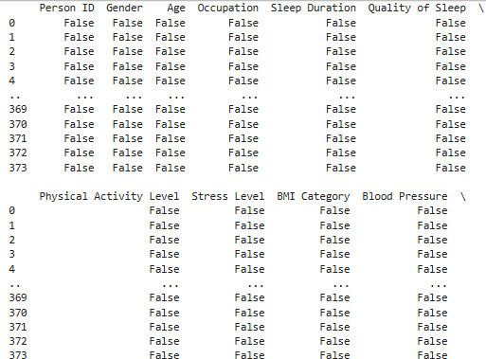

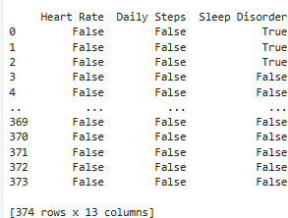
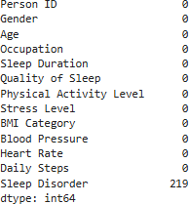

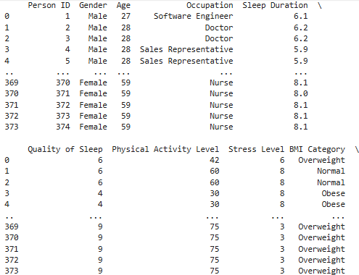

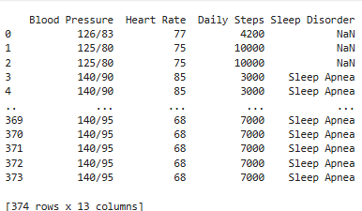
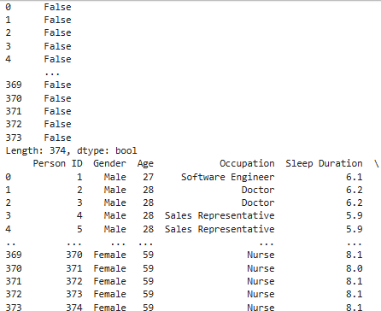
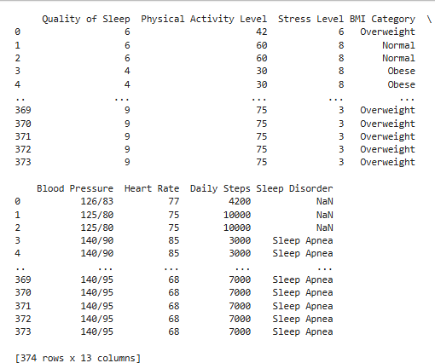

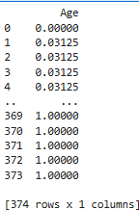
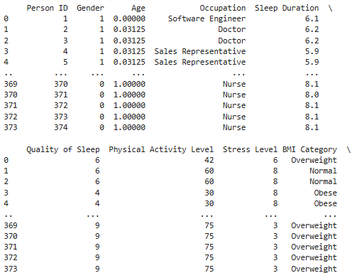
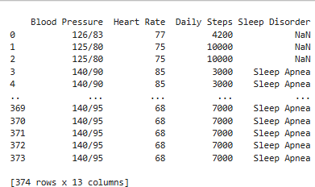

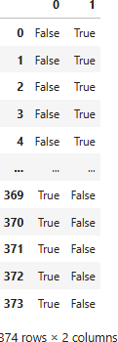

Result:

